**HOSTEL MANAGEMENT SYSTEM**

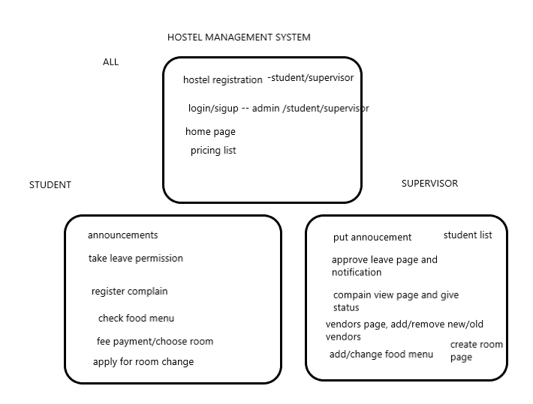

1. Admin Section:
   1. Create Room type Page 🡪 The admin creates new type of room

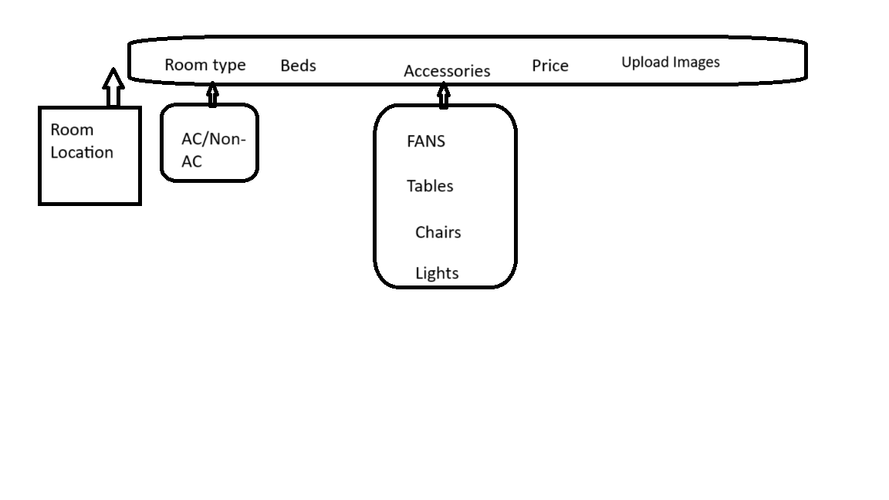

|  |  |  |  |  |  |  |  |
| --- | --- | --- | --- | --- | --- | --- | --- |
| Room_type_id | No_of_beds | Fans | Tables | Chairs | lights | price | image |
|  |  |  |  |  |  |  |  |
|  |  |  |  |  |  |  |  |
|  |  |  |  |  |  |  |  |

* 1. Rooms 🡪 with this table we can understand how many beds are booked in a particular room.

|  |  |  |  |  |
| --- | --- | --- | --- | --- |
| Room_number | Room_type_id | Total_beds | Available_beds | occupied_beds |
|  |  |  |  |  |
|  |  |  |  |  |

* 1. Allocated_students 🡪 there should be some mechanism to understand whether the room is available or not

This table is just to know the student booked which room and also which bed is allocated for the particular student?

|  |  |  |  |
| --- | --- | --- | --- |
| Student_id | Room_number | Bed_number |  |
|  |  |  |  |

This is my design idea for adding new rooms by admin. The upper row is for adding new flour. The one block is treated as one flour.

Then below there should be one box in which we can put the number of rooms in this flour. Based on this we can generate the room number as “block-flour-room_number”, for ex. “AB-0-15”.

|  |  |  |  |  |  |  |
| --- | --- | --- | --- | --- | --- | --- |
|  |  |  |  |  |  |  |

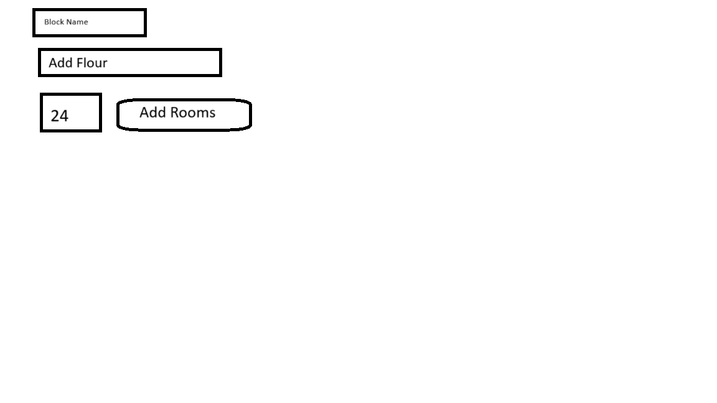



|  |  |  |  |  |  |  |
| --- | --- | --- | --- | --- | --- | --- |
|  |  |  |  |  |  |  |
|  |  |  |  |  |  |  |
|  |  |  |  |  |  |  |
|  |  |  |  |  |  |  |
|  |  |  |

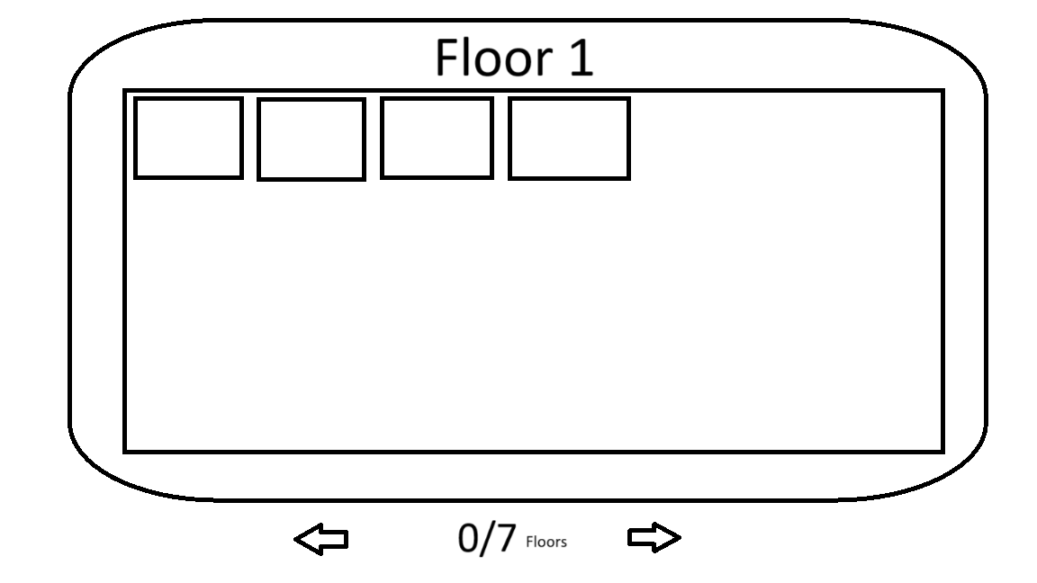

* 1. Create Room Type UI design: This section tells how to add the room type in which how many fans are there and image also can be uploaded.

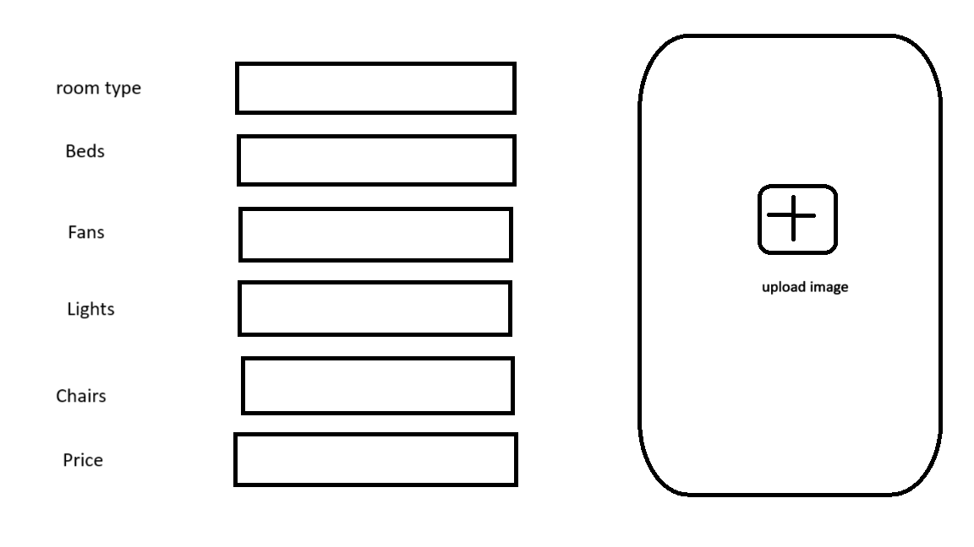

1. Student Section:
   1. Hostel registration: login, registration: name, DOB, Registration number, password

**Role_type_table:**

|  |  |
| --- | --- |
| Role_type_id | Role_type_name |
| 1 | Admin |
| 2 | supervisor |
| 3 | student |

**User_table:**

|  |  |  |  |  |  |
| --- | --- | --- | --- | --- | --- |
| User_id | Role_type_id | reg_number | name | password | DOB |
| 1 | 3 | 20MIP10019 | Bhanu | 1234 | 09/02/2002 |
|  |  |  |  |  |  |

**Complain_table:**

|  |  |  |  |  |  |
| --- | --- | --- | --- | --- | --- |
| **Complain_id** | **Complain_type** | **User_id** | **item** | **description** | **status** |
| **1** |  |  |  |  |  |
|  |  |  |  |  |  |

* 1. After registration student should enter into room choose page
  2. There will be a complain section by which the student can register the complain for the room or any other violence activity

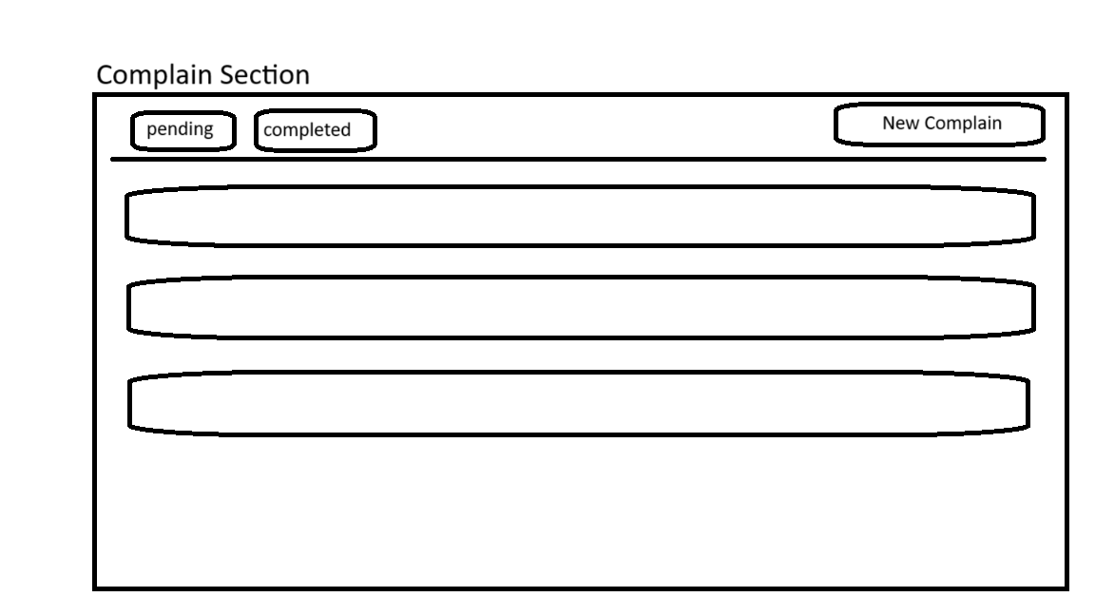

New Complain 🡪